

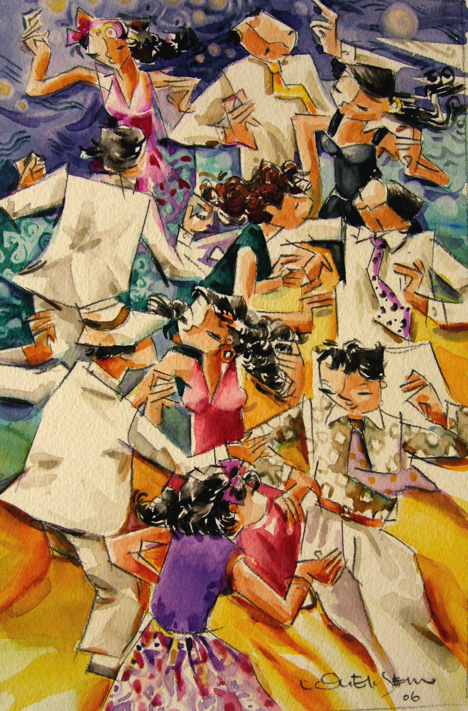

THE HERITAGE

Taxi Dancing
Patrons obtained booklets or coupons that enabled them to ‘buy’ a dance with their favourite dance hostess (called joget girls)

